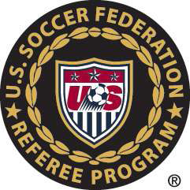
CAL NORTH CONCUSSION/HEAD INJURY PROTOCOL

Referees are to follow the below procedure regarding possible concussion/head injury to players until given further directions/guidelines:

1-If the Referee has a situation where a player or players have had a collision (with players or with the ground or with a hard object such as a goal post, etc) and that player or players displays any of the symptoms listed under the concussion protocol (under www.calnorth.org under Concussion Protocol), the Referee is to ask that the player(s) leave the field and to ask the coach to make sure that that player(s) does not return to play during that match. The Referee is not to make any kind of medical prognosis.

2-The Referee will pull that player(s) pass from the team’s passes.

3-If this is a Cal North match (Recreational or CCSL match) the Referee is to mail the pass(s) to the address immediately listed below. This only pertains to Cal North matches not Nor Cal matches. Mail the Player Pass(s) along with a note indicating that the player(s) was/were asked to leave the field for a possible head injury to:

Cal North Youth Soccer
1040 Serpewntine Lane, Suite 201
Pleasanton, ca 94566

4-After the game is concluded, the Referee shall write/report on the game card and/or online game reporting protocol the name of the player(s) sent off for possible head injury, the number of the player(s), the team name of the player(s), and the minute of the match that the Referee asked the player(s) to leave, and clearly stating that the player(s) were sent off for possible head injury.

Again, if the Referee determines that there MIGHT be a possible concussion/head injury (not heatstroke, heat exhaustion), all the Referee is to do is to have the player(s) leave the field, does not have the player(s) return during that match, pulls the player(s) pass, writes the report per League Game Protocol, and mails the pass to the above listed address.

Additional information/guidelines to follow.

